Ultrasonic Servo Radar Project

Description:
This project simulates a simple radar system using an ultrasonic sensor mounted on a servo motor. The servo rotates left and right while the ultrasonic sensor measures distance and scans the surroundings.
Block Diagram:
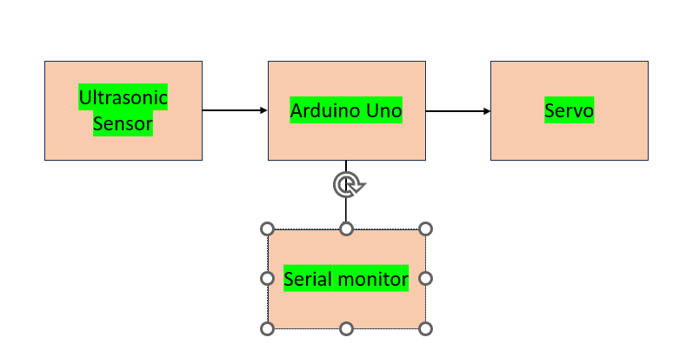
Pinout / Circuit Connection:
Servo Motor → PWM Pin (e.g., D9)
Ultrasonic Sensor Trig → D10
Ultrasonic Sensor Echo → D11
VCC and GND common for all components
Components Required:
- Arduino UNO
- Ultrasonic Sensor (HC-SR04)
- Servo Motor (SG90)
- Jumper Wires
- Breadboard (optional)
Working Principle:
The servo motor rotates from 0° to 180° while the ultrasonic sensor takes distance measurements. Each angle's distance is recorded to simulate radar scanning. The data can be viewed on the serial monitor or plotted.
Operation (Step-by-Step):
1. Connect the ultrasonic sensor to the Arduino.
2. Connect the servo motor to a PWM pin.
3. Upload the radar scanning code.
4. Servo rotates, sensor detects distance at each angle.
5. Output shown on Serial Monitor.
Arduino Code:
#include <Servo.h>
Servo s;
int trig = 10, echo = 11;
long duration; int distance;
void setup(){
Serial.begin(9600);
s.attach(9);
pinMode(trig, OUTPUT);
pinMode(echo, INPUT);
}
void loop(){
for(int pos=0; pos<=180; pos+=10){
s.write(pos);
delay(200);
distance = getDistance();
Serial.print(pos);
Serial.print("° : ");
Serial.print(distance);
Serial.println(" cm");
}
for(int pos=180; pos>=0; pos-=10){
s.write(pos);
delay(200);
distance = getDistance();
Serial.print(pos);
Serial.print("° : ");
Serial.print(distance);
Serial.println(" cm");
}
}
int getDistance(){
digitalWrite(trig, LOW);
delayMicroseconds(2);
digitalWrite(trig, HIGH);
delayMicroseconds(10);
digitalWrite(trig, LOW);
duration = pulseIn(echo, HIGH);
return duration * 0.034 / 2;
}
Conclusion:
The Ultrasonic Servo Radar project demonstrates how servo rotation combined with ultrasonic sensing can be used to scan and map surroundings in a simple and effective way.

